Xoel – Pré – Nova Linha Vivo

;change-number 5511971402010

{"intent": "intent.trigger.altas.pos"}

Cep genérico – 03135020

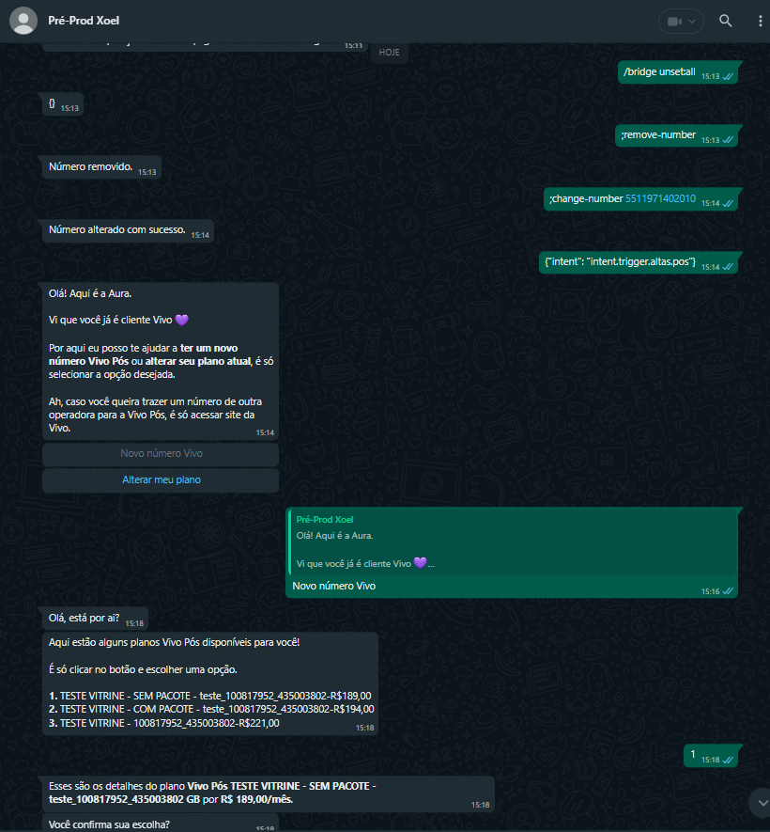

Outro cpf valido

